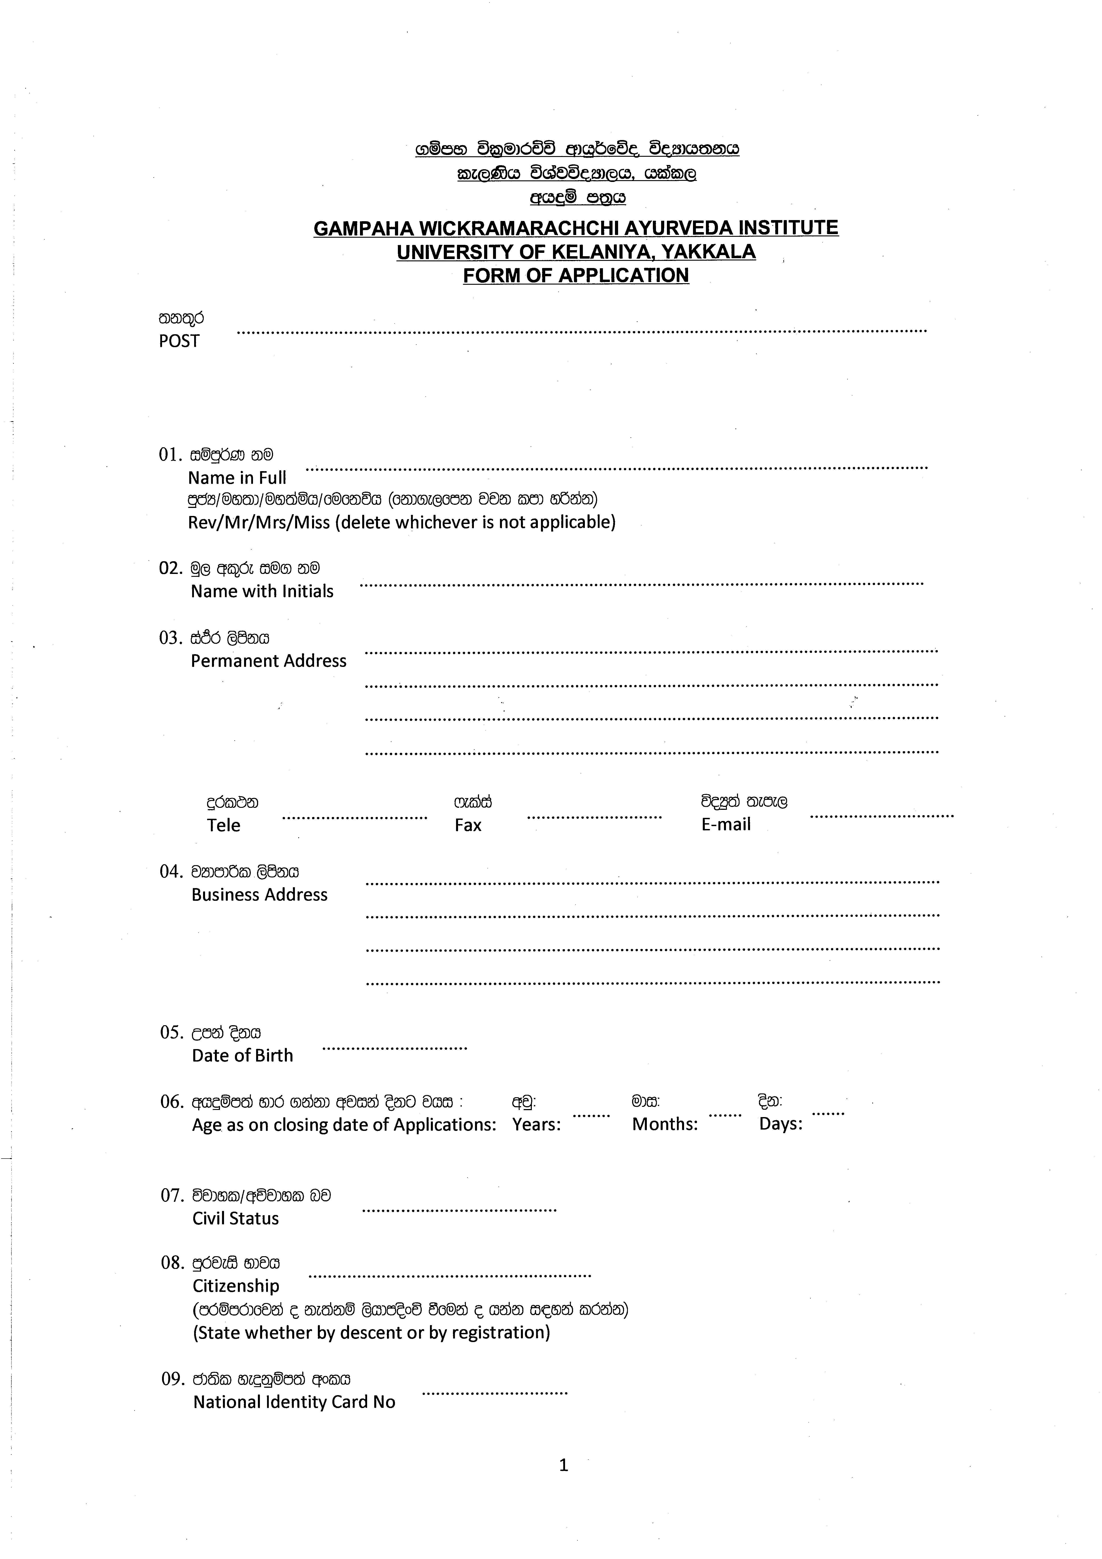
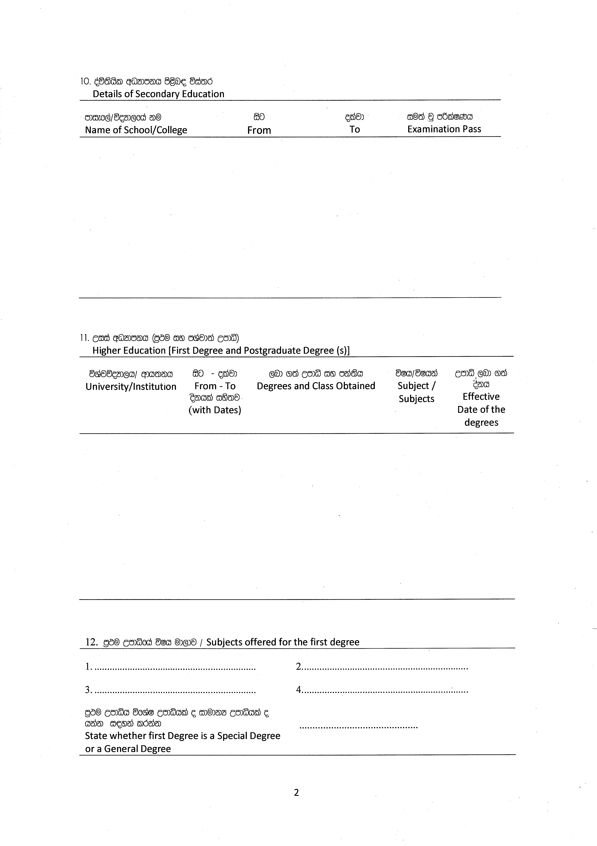
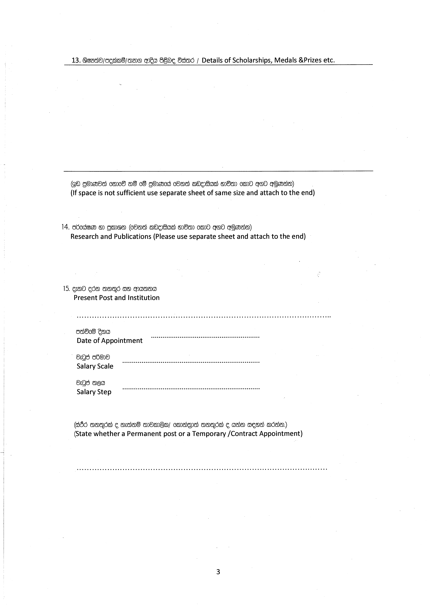
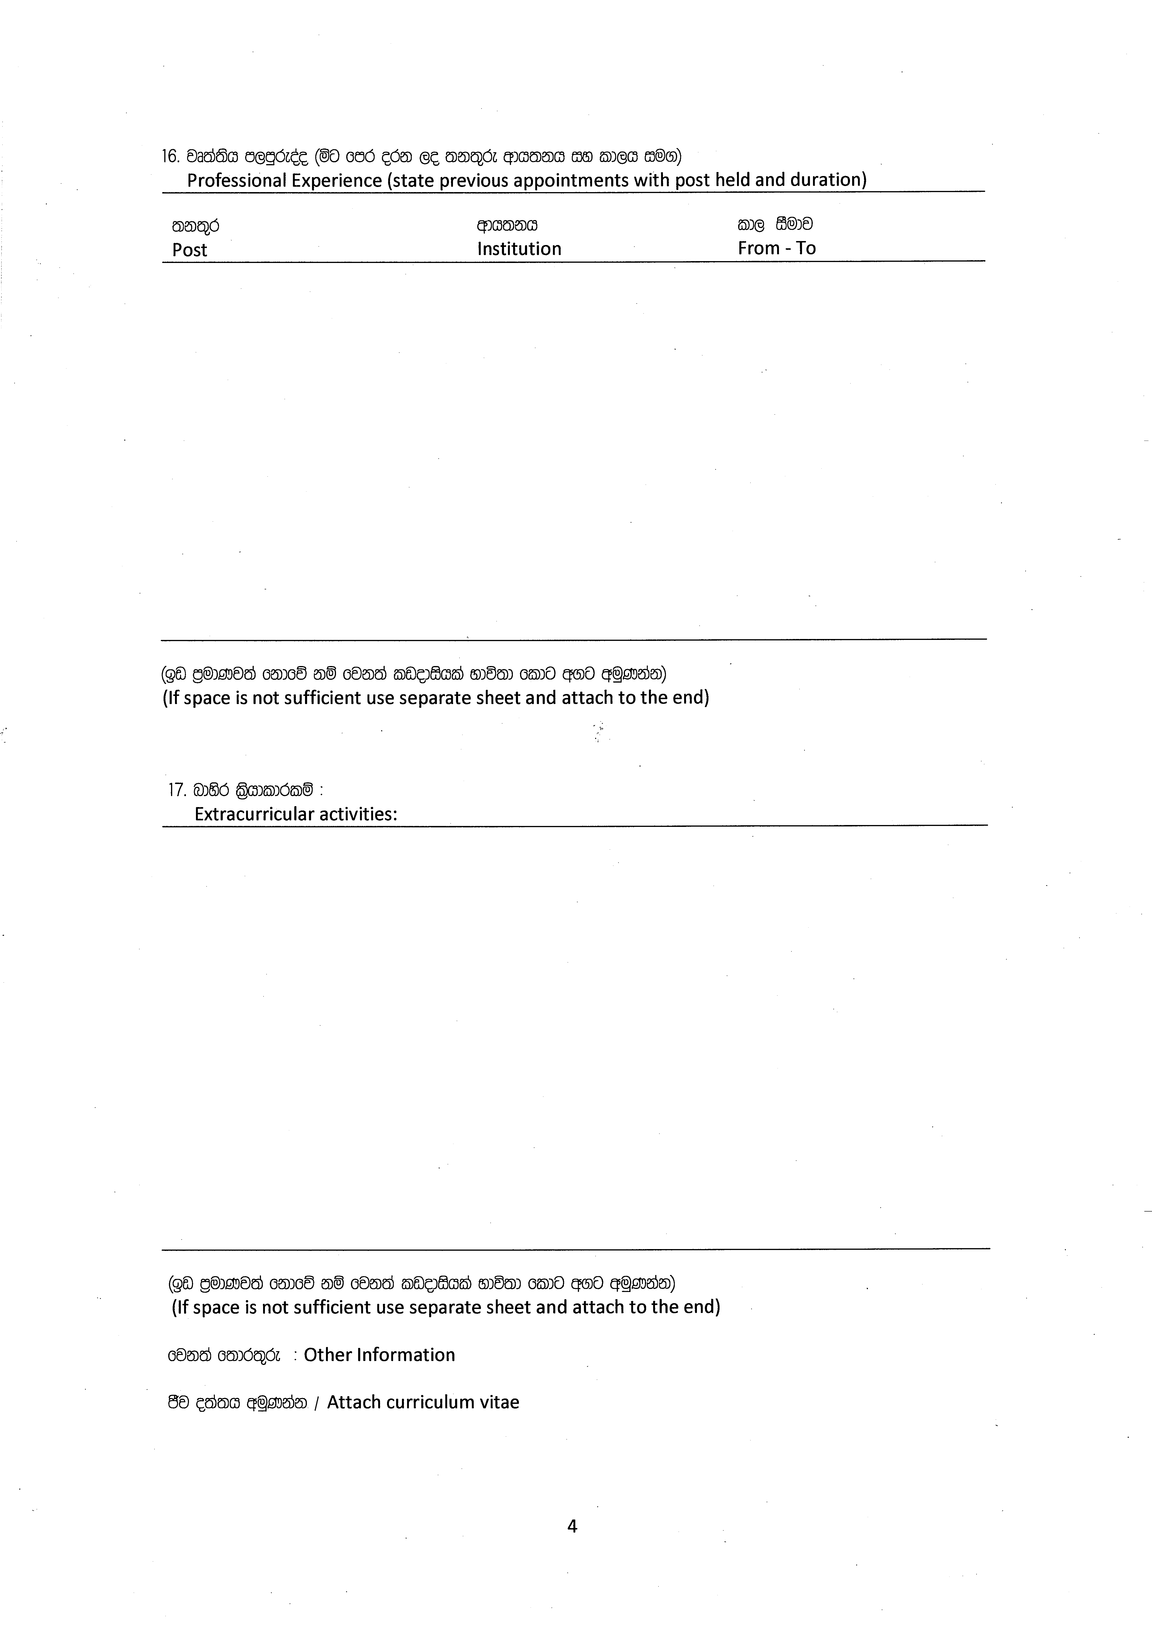
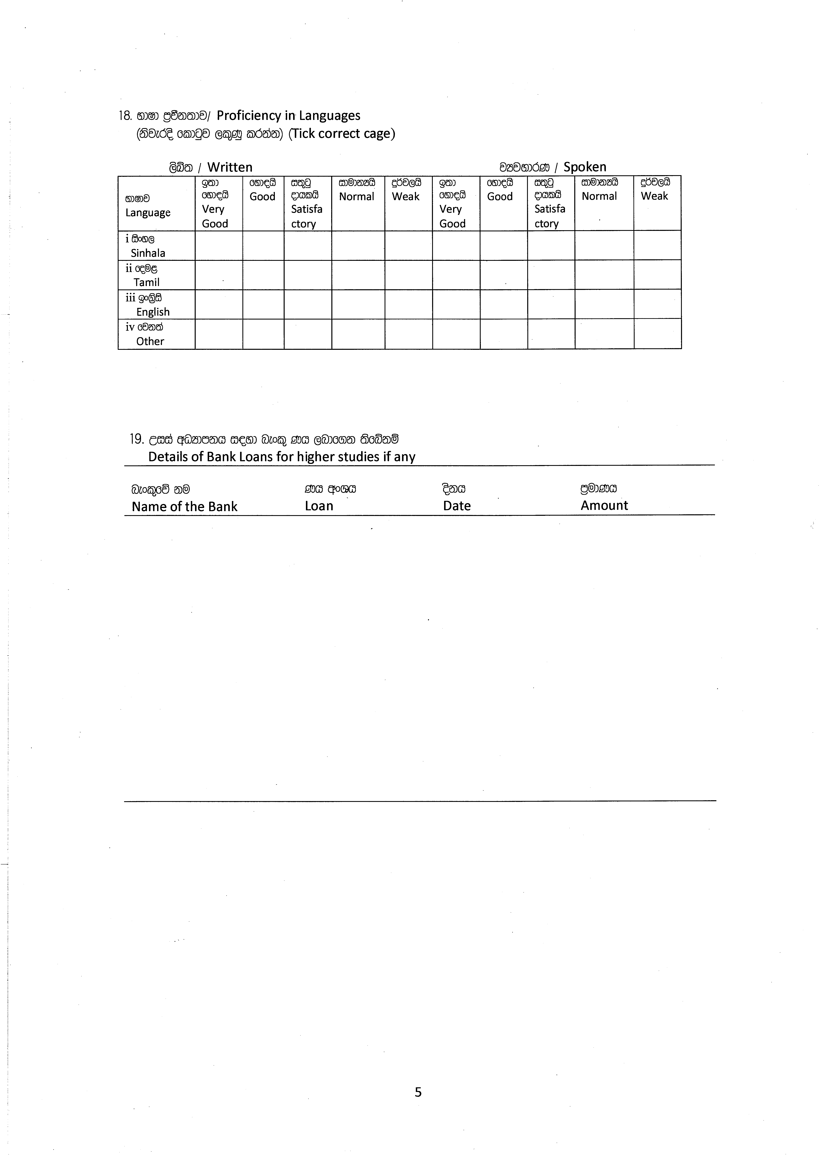
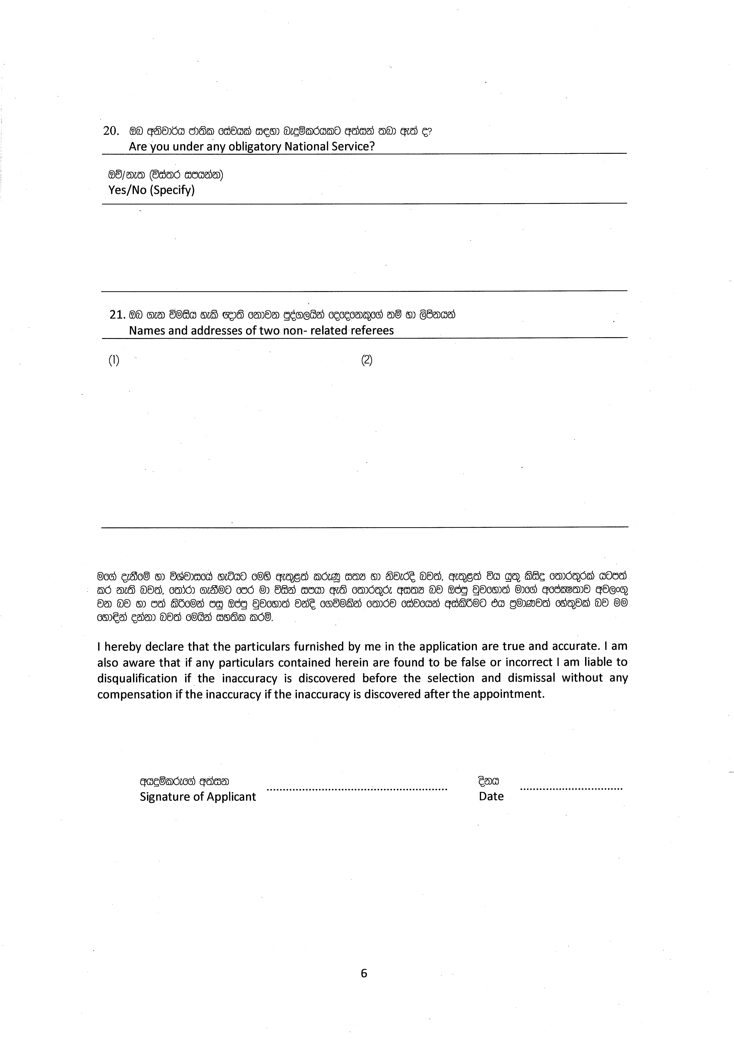

rdcH wxYfha wh÷us lrejka ioyd muKhs
For Public Sector Candidates

…………………………………………………………………………………………………;k;=r ioyd ……… ........................................................................uhd/ñh/fuh úiska bosrsm;a lrkq ,nk whoqï m; fï iu. tjk w;r hï fyhlska whoqïlre tlS ;k;=r ioyd f;dard.kq ,enqjfyd;a Tyq$weh fiajfhka ksoyia l< yels /fkdyels nj iy;sl lrñ.

Application for the post of ...............................................................................................
Submitted by …………………………………………………………….is Forwarded herewith.
If he/she is Selected for the said post he/she can/cannot be released.

………………………………………………
wdh;k m%Odkshdf.a w;aik

ku
Name:

;k;=r
Designation:

uQødj
Seal:

lreKdlr wod< iy;slj, Pdhd msgm;a wuqKkak
Please attach photocopies of the relevant certificates to the application

7

